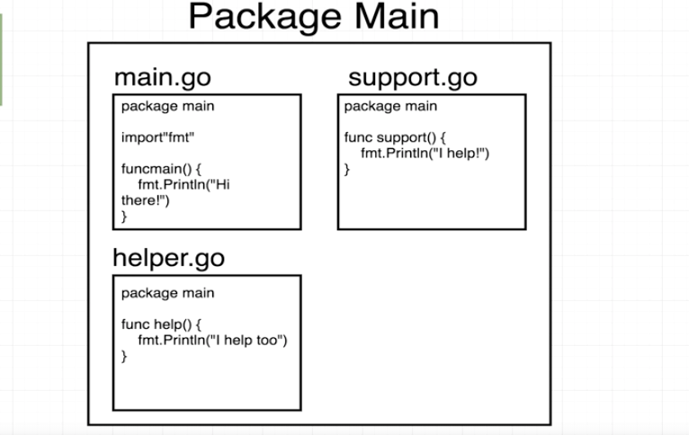

What is mean by package ?

=> Package is nothing but common of source code files. You can think it is project/workspace.It has many related files with extension .go.

Why used "main" in the package name?

=> it is used to create executable , if main is **NOT** there then it will create re-usable/ library code.

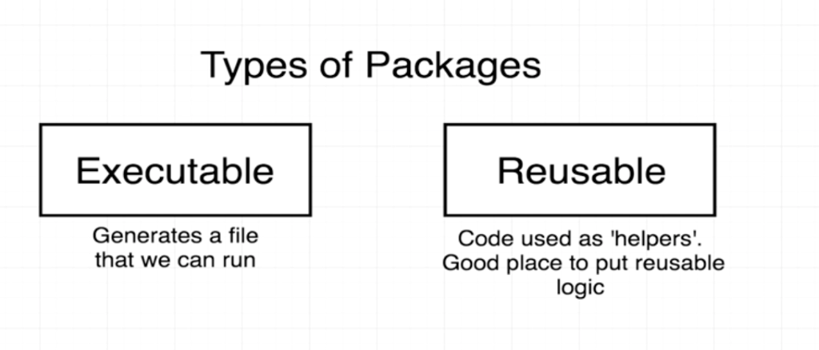

What used of import ?

=> it include other package in our current package/module, here **fmt** is used as standard library package, which give access to our main package